Keepsake Goldendoodles 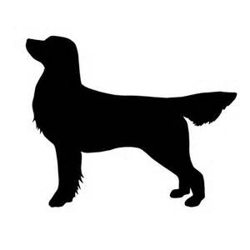
Traveling Safely home with your puppy.
Many puppies can experience motion sickness until they get used to riding in a car. The puppy may whine, cry, vomit or salivate (mildly to profusely) during this process.
- It’s important that your puppy is always properly secured and protected while riding in the car.
- A properly fitted and padded harness
- A Safety strap that hooks to the puppy’s harness and locks into your seatbelt fastener.
- A rubber backed rug placed on the seat of your car under the puppy will provide added traction and comfort as well as protecting your car seats.
- A Crate for your puppy to ride in, the crate should have plenty of room for your puppy to stand up, lay down and turn around easily. There should be a fabric/fleece crate pad covering the floor of your puppy’s crate to prevent the puppy from sliding around in the crate. Most puppies do better if the crate is mostly covered with a blanket or throw (don’t cover the crate door unless necessary) most puppies do best with a family member riding beside them. Place the crate door facing the family member beside him/her.
- Give the puppy a bully stick to chew on, this can be a wonderful and rewarding distraction for them.
- If your puppy seems very stressed about traveling in the car, an adult family member with a towel covering their lap can ride with the puppy on their lap in the back seat, this will usually calm the puppy right away.
- Very Important – proper potty breaks while traveling. Never use roadside rest areas, restaurants, gas stations, hotels or any canine common lawn areas. These areas harbor many parasites and viruses that your puppy’s immune system is not yet strong enough to keep them from getting. Most puppies can travel as long as 6 hours without a break.
- If your puppy is telling you they need a break PLEASE find an area that other people would most likely not exercise their dogs at. Examples – a church lawn, business office lawn other than a vet.
- Make sure you carry poo bags and always clean up after you puppy immediately.
- If your puppy is riding great you can offer small amounts of water along your travels home if and when needed.
- Puppy car riding supplies – 2 small trash bags, baby wipes, paper towels and a couple of humane towels for extra clean bedding if needed. It is best to keep these supplies in your car for future rides as well.
- Every puppy gets used to the car at their own pace. Short positive rides with as few turns, stops or hills are the best. Limit amount of food offered before car rides until they are adjusted.

